Tatton Wildlife Newsletter – Autumn
As the days become shorter, nature prepares for winter, interesting changes are taking place. Bird migration is underway, the deer are rutting, and the fungi season is at its peak. It really is a wonderful time to get out and explore the parkland.
Birds
The summer visitors will now move south and visitors from the north join us for our relatively mild winter. Redwings and fieldfares, thrushes from Scandinavia, arrive and feed on berries. Meadow pipits will arrive from their montane breeding grounds and wildfowl numbers will increase on the meres.
Two scarce summer visitors were recently seen in Millennium Wood. A juvenile redstart and ten spotted flycatchers. The former has bred here in the past but very infrequently and the latter, probably a family party, is becoming very uncommon.
Autumn Woodlands
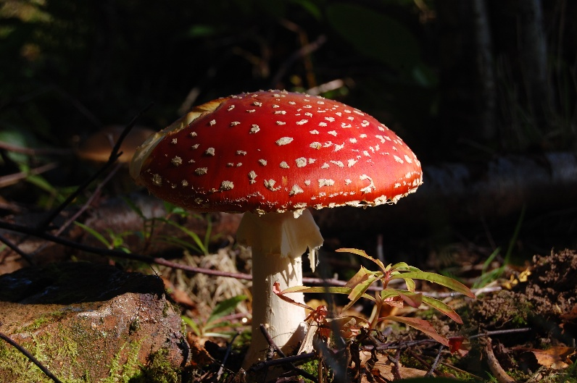
Autumn woodlands are valuable habitats providing essential resources and conditions for many species preparing for winter. Falling seeds, nuts and fruits (like acorns, berries and beech nuts) provide food for many bird species, plus animals like deer and squirrels. Fungi flourish in autumn, feeding insects and animals while forming vital underground networks with trees (mycorrhizae). Oak and birch trees are good places to look for fungi. The classic red and white spotted toadstool (Fly Agaric) is often spotted near a birch. Beefsteak fungus has a dark red, sticky upper surface and is a bracket found growing on oak trees. Please be aware that some fungi species are poisonous so look, but please don’t taste, pick or touch!
Leaves are the powerhouses of trees, providing its food and a mature oak tree can also provide enough oxygen for 10 people for a year. As the leaves start to die in autumn, the tree takes back reusable proteins and green chlorophyll, revealing the yellow and red pigments produced by sugars remaining in the leaf. Leaf litter and rotting wood provide perfect habitat for insects, spiders and decomposers like beetles and earthworms. Many insects lay eggs in the soil or leaves to overwinter, ensuring spring emergence. Animals like hedgehogs and bats rely on autumn woodlands to fatten up and find secure hibernation sites before temperatures drop for the winter.
Mining Bees
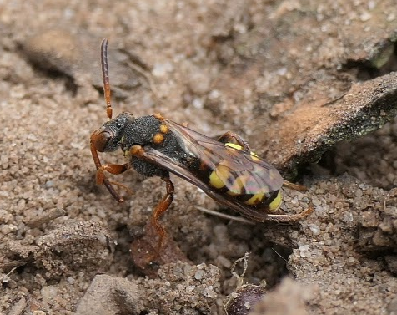
During the summer, one of our visitors has been studying mining bees in the park. Admittedly a very niche subject and generally overlooked, he has discovered that we have some real rarities here. The sandy, exposed banks that are trampled and grazed by deer and sheep provide ideal conditions for them. Areas around the Mosses and Fishponds have proved especially valuable. We are one of only two sites in Cheshire that have tormentil mining bee. A recent colonist of Cheshire, the short-fringed mining bee was seen as was its ‘cuckoo’ the variable nomad bee, which was a new species for Cheshire. Yellow-legged mining bees and their ‘cuckoo’, painted nomad bee along with good numbers of orange-legged furrow bees were also recorded.
Deer
Autumn is the time when the deer are rutting. The males compete to mate with the females, making themselves look and sound as intimidating as possible. They do this by wallowing in mud and adorning their antlers with grass. The red deer bellow loudly whilst the fallow have, what can only be described as a rasping, belching snort! The fallow deer can be seen parallel walking, weighing each other up before challenging a rival.
Fighting is a last resort when the stags and bucks lock antlers together in a show of strength to determine the dominant animal. The stronger stag will keep more hinds together in his harem and a dominant buck will attract more does to his ‘stand’.
PLEASE KEEP 50m AWAY FROM THE DEER. THEY CAN ACT AGGRESSIVLY DURING THE RUT.
Compiled by Tatton’s Ranger Team

